##### St Andrew’s Church

Orford with Longford

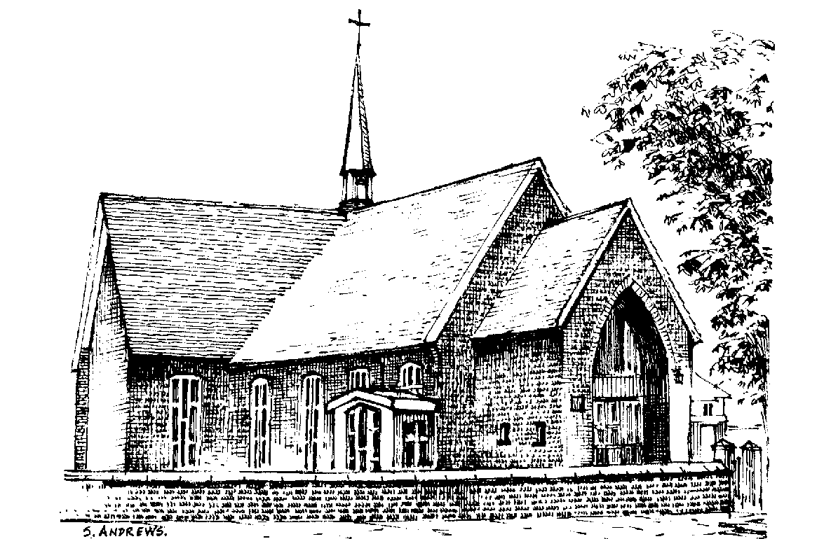

Hilda Smith

Wednesday 27th December 2017

#### Introduction

**All:** **Merciful Father, hear our prayers and comfort us; renew our trust in your Son, whom you raised from the dead; strengthen our faith that all who have died in the love of Christ will share in his resurrection; who lives and reigns with you, in the unity of the Holy Spirit, one God, now and for ever.**  **Amen**

**Hymn: “All things bright and beautiful”**

*All things bright and beautiful,*

*all creatures great and small,*

*all things wise and wonderful,*

*the Lord God made them all.*

Each little flower that opens,

each little bird that sings,

he made their glowing colours,

he made their tiny wings:

The purple headed mountain,

the river running by,

the sunset, and the morning

that brightens up the sky:

The cold wind in the winter,

the pleasant summer sun,

the ripe fruit in the garden,

he made them every one:

He gave us eyes to see them,

and lips that we might tell

how great is God almighty,

who has made all things well:

The Ministry of the Word

**The Scriptural Reading** (Verses from Psalm 34 and Rev 21. 1-7)

*At the end of the reading:*

This is the word of the Lord

All: Thanks be to God

**The Address**

**Hymn: “Make me a channel of your peace”**

Make me a channel of your peace.

Where there is hatred let me bring your love.

where there is injury, your pardon, Lord,

and where there's doubt, true faith in you.

Oh Master, grant that I may never seek

so much to be consoled as to console,

to be understood, as to understand,

to be loved, as to love with all my soul.

Make me a channel of your peace.

Where there's despair in life, let me bring hope.

Where there is darkness, only light,

and where there's sadness, ever joy.

Oh Master, grant that I may never seek

so much to be consoled as to console,

to be understood, as to understand,

to be loved, as to love with all my soul.

Make me a channel of your peace.

It is in pardoning that we are pardoned,

in giving of ourselves that we receive,

and in dying that we're born to eternal life.

**The Prayers:**

## Each section concludes:

Lord, in your mercy

**All: hear our prayer.**

## After the final section:

**God of mercy, entrusting into your hands all that you have made and rejoicing in our communion with all your faithful people, we make our prayers through Jesus Christ our Saviour. Amen.**

The Lord’s Prayer

**Hymn: “How great thou art”**

O Lord my God! When I in awesome wonder

Consider all the works Thy hand hath made,

I see the stars, I hear the mighty thunder,

Thy power throughout the universe displayed:

*Then sings my soul, my Saviour God to Thee,*

*How great Thou art! How great Thou art!*

*Then sings my soul, my Saviour God to Thee,*

*How great Thou art! How great Thou art!*

When through the woods and forest glades I wander

And hear the birds sing sweetly in the trees;

When I look down from lofty mountain grandeur,

And hear the brook, and feel the gentle breeze;

*Then sings my soul ...*

And when I think that God his Son not sparing,

Sent Him to die - I scarce can take it in;

That on the cross my burden gladly bearing,

He bled and died to take away my sin:

*Then sings my soul ...*

When Christ shall come with shout of acclamation

And take me home - what joy shall fill my heart!

Then shall I bow in humble adoration  
And there proclaim my God, how great Thou art!

*Then sings my soul ...*

Commendation and Farewell

All: Heavenly Father, in your Son Jesus Christ you have given us a true faith and a sure hope. Strengthen this faith and hope in us all our days, that we may live as those who believe in the communion of saints, the forgiveness of sins and the resurrection to eternal life; through Jesus Christ our Lord. Amen.

Acknowledgement: *Common Worship: Pastoral Services,* material from which is included in this service, is copyright © The Archbishops’ Council (2000)